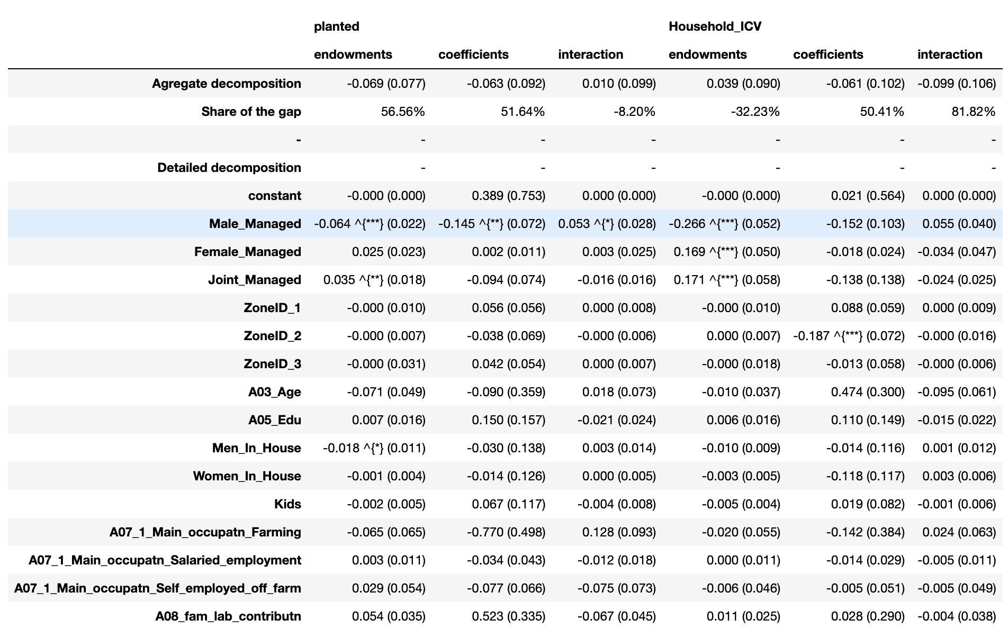

Who is managed what plot
Overmanaging.

Only variable where DNA fingerprinting. Managed.
Take samples from your fields
take and go away.

Judgment , what I management.
Genetic analysis.
“True is coming for fingerprinting. Showing to the field.

All constructed by only Male, only Female
Show how significant are with the independence.

Trully on male, female.
Coefficients, that are bias.

Is bias, finger printer data.
Different regressions. % females, impact of gender.

Bias, endowment, and how it is bias.
Invalid, and correlations..
Examinations. Correlations (right independent variable).

2 sector.

